Cybersecurity Core Concepts: A Beginner's Guide
- Name: GK Shanjeev Kumar
- Date: September 24, 2026
- TryHackMe Profile: progamerazerz

1. Introduction
Cybersecurity is built upon fundamental principles that protect data, systems, and users from malicious actors. This document explores the CIA Triad (Confidentiality, Integrity, and Availability) along with two additional core concepts: Authentication vs. Authorization and Threat vs. Vulnerability vs. Risk. Each concept includes a concrete real-world scenario to explain how it applies or is violated.

2. Confidentiality
- Definition: Confidentiality ensures that sensitive or private information is accessed only by authorized individuals and kept away from those lacking permission.
- Real-World Scenario: Healthcare Data Breach.
  - What happened: A hospital database containing patient medical records and social security numbers was left unsecured on an open-cloud server without proper password protection or encryption.
  - Why it applies/is violated: An unauthorized third party discovered the open server and downloaded thousands of private files. This is a direct violation of confidentiality because sensitive data was exposed to individuals who had no legal or medical right to view it.
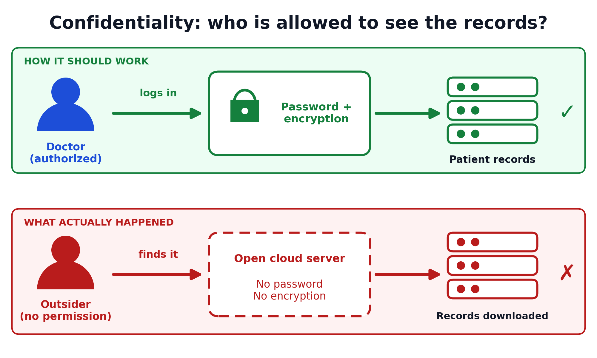
Figure 1 – Confidentiality: the hospital’s patient records are protected by a password and encryption in the intended setup, but were left open on the cloud server in the breach.

3. Integrity
- Definition: Integrity guarantees that data and systems remain accurate, complete, and trustworthy, preventing unauthorized modification, deletion, or tampering.
- Real-World Scenario: Banking Transaction Tampering.
  - What happened: A malicious insider intercepted an online wire transfer request between a customer and a vendor, subtly altering the destination bank account number and the transfer amount mid-transit.
  - Why it applies/is violated: The bank received altered data without realizing it was modified. This violates integrity because the core information (the transaction details) was tampered with by an unauthorized actor, rendering the data unreliable.
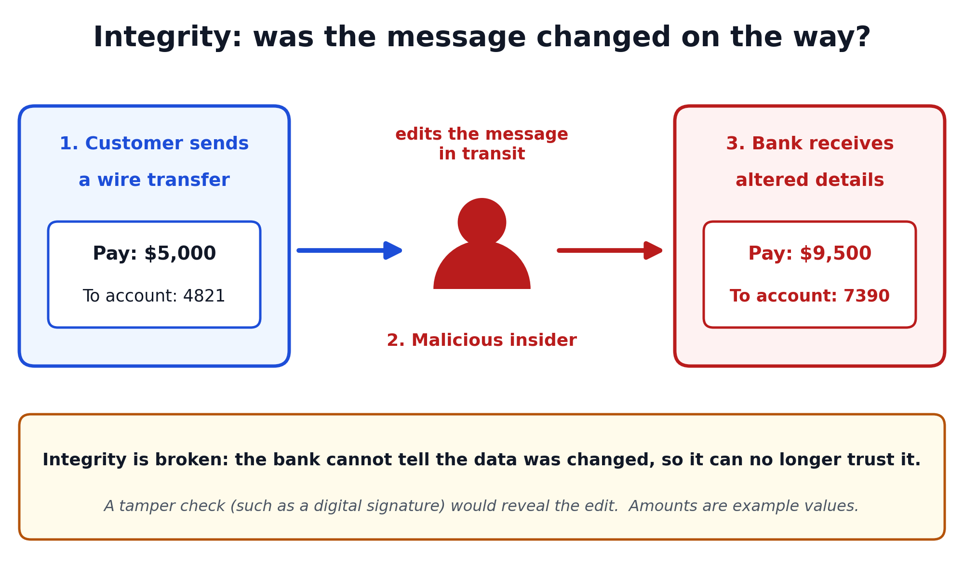
Figure 2 – Integrity: a wire transfer is altered in transit, so the bank receives different details from the ones the customer sent.

4. Availability
- Definition: Availability ensures that information, network resources, and services are accessible to authorized users whenever they need them.
- Real-World Scenario: Distributed Denial-of-Service (DDoS) Attack on an E-Commerce Site.
  - What happened: During a major holiday online shopping event, a malicious botnet flooded an online retailer's servers with millions of fake traffic requests simultaneously, crashing the website.
  - Why it applies/is violated: Legitimate customers trying to buy items were met with "Service Unavailable" error pages. This violates availability because the system resources were overwhelmed, rendering the service completely inaccessible to authorized users.
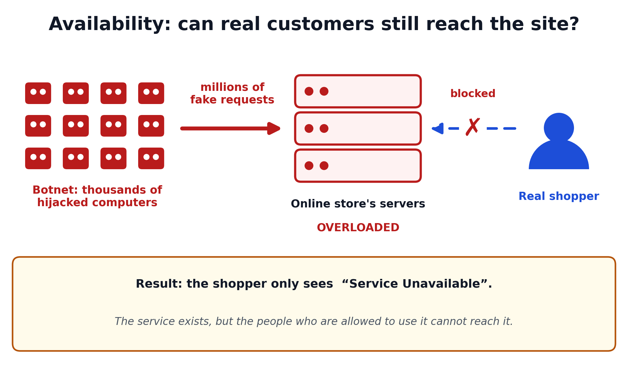
Figure 3 – Availability: a botnet floods the online store’s servers with fake requests, so real shoppers are blocked.

5. Authentication vs. Authorization
- Definitions:
  - Authentication is the process of verifying who you are (e.g., entering a username and password, or using biometric face-ID).
  - Authorization is the process of verifying what you are allowed to do or see once you are logged in.
- Real-World Scenario: Corporate Employee Portal.
  - What happened: An entry-level employee successfully logs into the company's human resources computer portal using their corporate badge and password (Authentication). However, when they try to access the executive payroll database files, the system blocks them with an "Access Denied" message.
  - Why it applies/is violated: Even though the employee’s identity was verified, the security system correctly recognized that their specific role did not grant them permission to view executive financial records (Authorization working properly). A violation occurs if a regular employee gains unauthorized entry to admin settings due to misconfigured permissions.
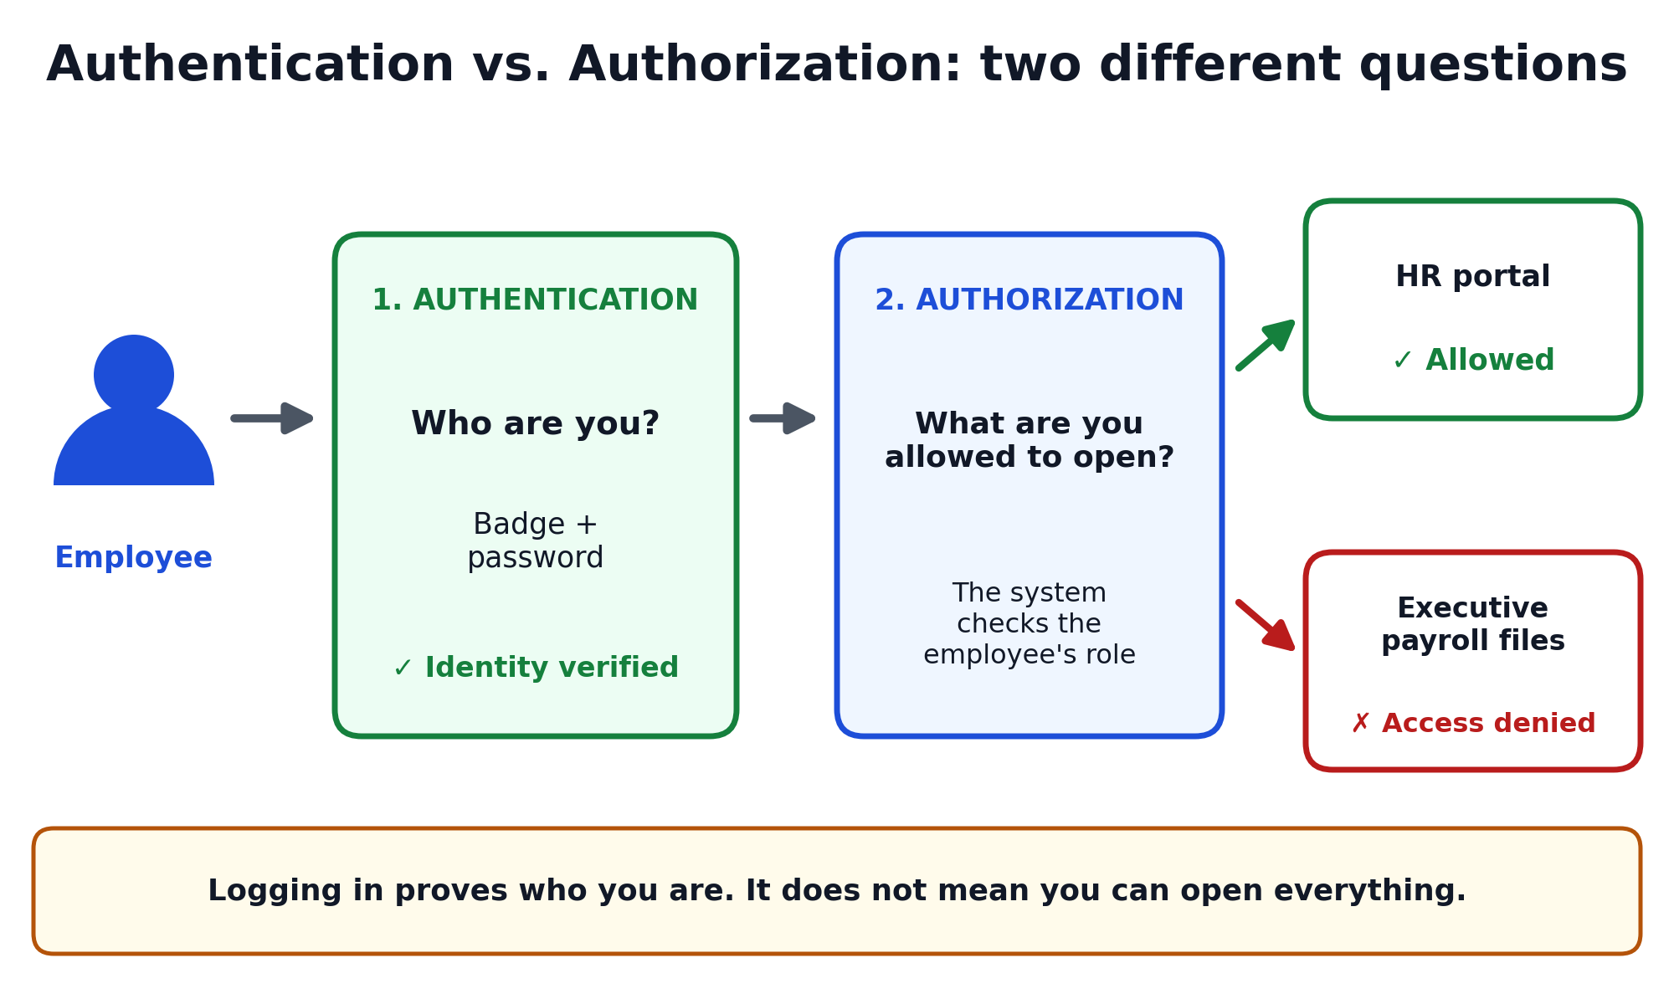
Figure 4 – Authentication vs. authorization: the employee is verified first (who are you?), then checked for permission (what may you open?).

6. Threat vs. Vulnerability vs. Risk
- Definitions:
  - Threat: Any potential danger or external force that could exploit a weakness (e.g., a hacker, malware, or natural disaster).
  - Vulnerability: A weakness, flaw, or gap in a system's design, implementation, or operation that a threat can exploit (e.g., outdated software).
  - Risk: The likelihood that a threat will exploit a vulnerability and the resulting impact or damage to the organization.
- Real-World Scenario: Outdated Operating System Software.
  - What happened: A company runs old computer software on its network that has a known security hole (a Vulnerability). Meanwhile, automated ransomware scripts scan the internet looking for that specific flaw (Threat). Because the company delayed updating its systems, an attack succeeds, resulting in millions of dollars in lost data and downtime (Risk realized).
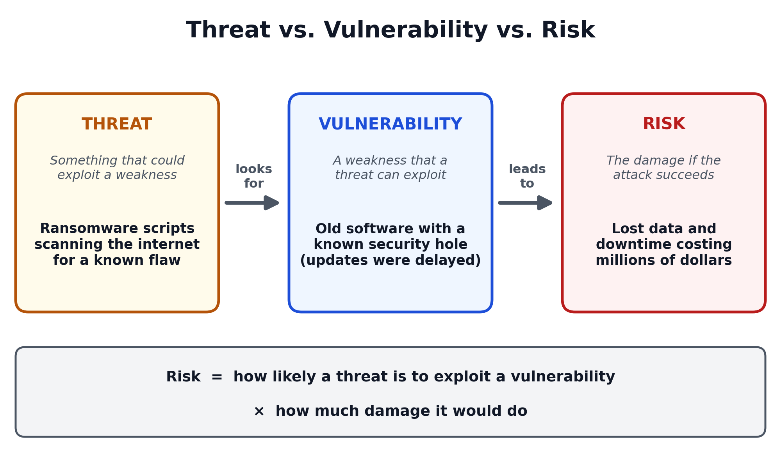
Figure 5 – Threat, vulnerability and risk: ransomware scripts (threat) exploit outdated software (vulnerability), creating the risk of costly data loss and downtime.

